Final Project

Eric Dahlenburg

IT476-01 Web Marketing & E-Commerce

August 11, 2006

Table of contents

Executive Summary ……………………………………………………………...3
Description of e-business idea ………………………………………………...5
Information on Products or Services to be Offered …………………….….6
Analyses of Overall Industry, Target Market, and Competition…..……...8
Marketing, Operational, Financial, and Managerial Plans …...9, 15, 16, 20
Identification of Critical Risks ………………………………………………...22
Exit Strategy …………………………………………………………………...…24
Mock-up of Homepage…………………………………………………….…….25
Summary of Required Internet Technologies ………………………………26
Logistics of Establishing and Maintaining your e-business site …..…...27

Executive Summary
Spacecoastsales.net is an online seller of humorous and adult items. What makes use unique is our products and marketing plan. Specifically, our products will be new and unique. They will not be sold anywhere else in great number. Our items have not already saturate the market place or will be available in brick and mortar stores.
The marketing is just as unique. We start by selling on EBay, while maintaining our own website. The sales on EBay bring customers to our site, were they can purchase similar items for less than the auction. Furthermore, they will be able to view all our products and opt in for our mailing list.
Concurrent to this, our website will be optimized for search engine ranking. We will have paid ad placement on the search engines and link exchanges with other sites to generate more traffic.
While this is just a brief overview, it should be noted that the business will break even by month 8 of the first year. In our three year plan, we forecast net year end profits of $67K and $125K in years two and three.
More importantly, after three years we will have sufficient web traffic and sales volume to have items built specifically for our business off-shore and shipped to us in cargo containers loads.

We will be able to take advantage of the near by Port Canaveral, a high tech inter-modal cargo center and free trade zone. This increase volume and reduced product cost will position us for the next logical step of being a distributor and wholesaler as well as e-retailer.
Our staff is experienced in international sales, custom manufacturing and distribution. We have a team that can build this company into the best source for adult novelty and humor items in the United States. We invite you to join us in this endeavor.

Description of e-business Idea
This e-business has two complimentary sales channels. Specifically, the
C to C market place of Ebay, and the separate site that sells the same and additional products on business website, Spacecoastsales.net. The idea is to initially generate exposure of the website through the online auctions on EBay. The target customers are repeat or directed customers from the EBay website. In addition, I anticipate new customers will discover our site through customer referrals and search engine results.
The products will be small items that can be shipped through USPS 2nd day flat rate envelopes. New products will be the life blood of this business, with staff emphasis on discovering, testing and selling new products. Our choice of inventory will be humorous and adult related items. This category has exhibited large sale growth, particularly with our target demographic, adult men, 25 to 45 years old.
We expect sales to grow, based on repeat EBay business, search engine placement, web link exchange, and the uniqueness of our products. Based on sales volume, we intend to contract manufacture some items and act as distributors for these and other items in the future.

Information on products or Services to be Offered
The products will be small items that can be shipped through USPS 2nd day flat rate envelopes. Furthermore, they will be unique, in that the market, and EBay, has not been saturated with the new products. Humorous and adult related items will be the primary choice of inventory. Because of the decaying nature of new products, only a small inventory of each product will be maintained at one time. ”Just in time” inventory practices will be used to insure that inventory won’t stagnate. We will also use drop shipping when ever possible to reduce inventory and costs. New products will be the life blood of this business, with staff emphasis on discovering, testing and selling new products. Product sources include trade magazines (Web Wholesaler, WholesaleCentral.com, CloseoutCentral.com, etc. ) Trade Shows (ASD/AMD), and Internet Searches. Additionally, we have manufactures in China who can build custom electronic, plush toys, and other items in huge quantities. It is the companies future intention to become a distributor of items in certain cases. Since these foreign factories manufacture and sell in huge quantities (cargo containers ), we intend to initially partner with other synergistic companies to split the cost of production. As an example, we might order a cargo container of Christmas themed plush toys in October, splitting the order with companies supplying coin-operated crane games. This sets the stage for eventually becoming a distributor of humorous and adult novelties. See figure 1 and 2 for examples of a typical item for sale.
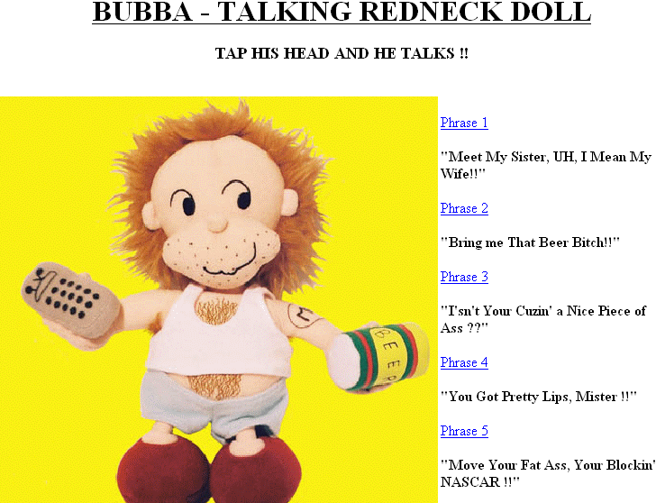
figure 1. Typical Product for our Target Demographic

figure 2. Typical Product for our Target Demographic
Analyses of Overall Industry, Target Market, and Competition
The retail merchandise industry as a whole is in great shape. Annual sales have increased every year, showing a great trend for the future expansion. This sales trend progressed throughout the economic turmoil’s that have effected other industries (911, Iraq war, energy costs).
Our business is a subset of the merchandise industry. We are most closely categorized as “Gifts, Novelty & Souvenir stores” (NAICS: 45322). The latest government statistic for this category are from 1997, and show that there are a total of 37, 285 retail stores with sales of over $14.5 billion.
The most similar retail store that sells like merchandise, is Spencer’s Gifts. This private company does not report financial figures. However, they have 700 retail stores in the US, UK, and Canada, with annual sales in 2003 of $400M. Spencer’s sells similar merchandise, but targets the 16 to 24 year old market (our is 24 to 45 year old male).
These examples are all retail, brick and mortar stores with very little web presence. Our business is completely web based with no brick and mortar stores. A search of on-line retailer that sell items similar to our site has very little results. Of the two sites that sell similar items, http://www.ehayes.com/ and http://www.smartplanet.net/default.asp , both are wholesaler and do not sell to the general public. Therefore, we are of the opinion that other than individuals selling on EBay, we are a unique e-business.
Additionally, since we will not sell items that are already saturated on EBay, our business is unique in its products and method of selling. A professional market analysis will be commissioned prior to financing to verify this assumption.
Marketing Plan
Executive Summary-
The overall marketing plan for our business is to start out with two sales channels, Spacecoastsales.net and our Ebay auction presence, spacecoastsalesdotnet. The idea is to generate repeat business from our sales on Ebay. All merchandise will be shipped with only our website labels attached to the item, offering reorder information. Our customers will receive periodic e-mails(opt in/out) offering new items for sale and continuing to remind them of our sales presence.
In addition, we will initially pay for search engine placement ads to further advertise our business. Ad placement is not intended for the long term. It is the responsibility of the IT Manager and company president to optimize our company website for search engine placement, both by the design of the site and the uniqueness of the products that we offer. Web link exchanges will be used with other synergistic businesses to generate further traffic to our site.
The goal to our plan is to gain the critical mass necessary to make our presence as a web retailer of unique and humorous adult items self sustaining.
Situational Analysis-
Internet sales are increasing at an enormous rate. In fact, US sales alone have increased by 20% each year since 2004(See figure 3). eMarketer estimates that retail e-commerce sales will increase an average 18.6% per year between 2005 and 2009 .The US e-commerce retail sale figure for 2006 was $169 Billion dollars, and the total revenues have increased each year since 2003 by roughly 20% (See figure 4). Internet user in the US have grown steadily, with almost 200 million user projected for 2007 (See figure 5).
These figures reflect the US market only. Our company will sell to the UK, Canada, Mexico, or anywhere that that is capable of making payment by credit card and can receive US mail.
Our international e-sales look even brighter. Some markets, like Central America, have seen a one year growth of 70% in broadband subscribers (see figure 6). This can only equate to a huge market for our products internationally as well as domestically. It is estimated that by 2007, the world will have 245.5 million broadband users (See figure 7).

“It took approximately 3.5 years to reach the first 10 million broadband subscribers and about the same time to go from 10 million to 100 million. eMarketer forecasts nearly 250 million broadband subscribers worldwide by 2007.”
“The next ten years will be marked by a deepening consumer acceptance of online purchasing. Powerful new search services will stir spending activity. Improved personalization technology will enable retailers to think more like their customers. And mobile phones, new wireless devices and multimedia messaging services will all support e-commerce.” E-commerce magazine
figure 3. On-line buyer and E-commerce retail sales
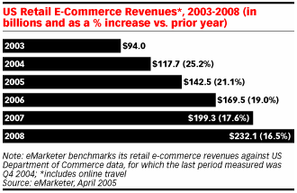
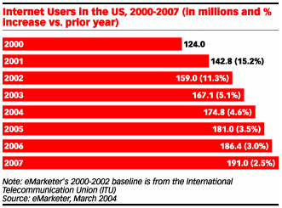
figure 4. E-commerce Revenues through 2008
Figure 5. US Internet Users 2000 – 2007

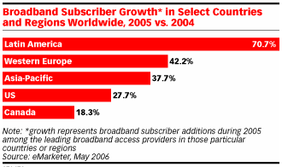
figure 6. Worldwide Growth in Broadband Subscribers
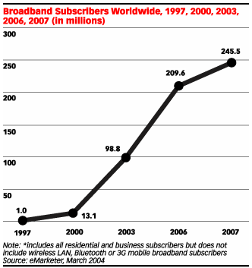
Figure 7. Worldwide Broadband users

Objectives, Strategies, and Tactics-
The first objective of the marketing plan is to use EBay to generate sales and refer customers to our own site. The second objective is to grow the site by optimize it for search engine placement and linking it to other sites using a link exchange. We want to switch the bulk of our sales from EBay to are own site over time.
The strategy for this is simple. We will initially sell our products on EBay. EBay will not allow a seller to advertise their site in auction copy. For this reason, our EBay user name is spacecoastsalesdotnet. In addition, all items will be shipped out with company tag advising customers how to re-order and view other items on our site.
Concurrent to this practice, out IT manager will work to further develop our site and optimize it for web search placement. We will also initially pay for ad placement on search engines to develop traffic. Couple this with our network of link exchanges and traffic should grow.
Budget and Performance Measurements-
With the exception of search engine ad placement, most of the website development and search engine optimization costs our covered by the IT managers budgeted salary. We have budgeted $5000 in advertising and promotional budgeting for year one. The majority of this budget is for ad placement. However, we have reserved a portion of the promotional budget for outside consultants who specialize in search engine placement.
Performance will be measured by link tracking reports available from the search engine and from our link exchange. Some of the payment formats are based on click through, so all web based advertising is tracked for payment and analysis.
Search engine placement will be tracked on a weekly basis for 6 of the most popular search portals. Depending on the results, an outside consultant may be contracted to improve our ranking. This will be tracked as well in order to judge the merits of the consultant.

Operational Plan-
Spacecoastsales.net is a limited liability Florida corporation. It is physically located at 1635 Yates Drive. Operating with 1000 square feet of inventory and office space. The actual website server is hosted by a reliable web host (GoHost.com) in California. Capital equipment includes 2 Pentium IV PC’s with ink jet and laser printers, Software, Cable modem, Router, File cabinets, Postage scale, and an inventory of office supplies. Since this is a separate area of the presidents principle residence, overhead cost are very low.
Additional warehouse space is available within 1/8 mile of this location at a very reasonable market rate. The facility has already agreed to reconfiguring our storage space based on our needs.
Larger office and warehouse space is available in Port Canaveral, 5 miles to the East. Port Canaveral has a modern cargo container facility and is also a “Free Trade Economic Zone”. This will further facilitate our expansion into importation of Chinese goods.

Financial Plan-
Initial first year expenses are detailed in Figure 8, below:
Figure 8. Estimated First Year Expenses
Equity in Start-up-
Seed Money of $100,000 will be secured using a Home Equity credit line with the principles main residence as collateral. A credit line allows for better control of expenses when purchases are made as needed.
Combined with the moderate income of the first year sales, it is the intent of the company to pay down the credit line principle whenever possible. Furthermore, the choice to bootstrap the seed money instead of using a venture capitalist or other sources was based on the more desirable financial arrangements that are offered an already existing company when searching for growth funding or an IPO.
Bootstrapping also allows for more freedom in the business course after the initial year. First round funding might not be necessary after the first year if sales and margins hold to our pro forma estimates.
First round funding might be put off until a beneficial expansion opportunity presents itself. An example might be the need for a warehouse for inventory. Property values can change rapidly in this area. It may be wise to rent space until a suitable property becomes available for purchase. Concurrent to the warehouse plan, the business might use our local ports free trade zone to purchase inventory directly from the foreign manufactures in cargo container quantities. These are plans that require 1st round equity funding.
Figures 9, 10, and 11 depict first year projected income, three year projected income statement, and planned cash flow. It is significant to note a break even point in month eight of the first year, with profits of over $100K in year three. It is at this point that the business will move more heavily into the importing and distribution side of the business.
We intend to look to equity funding to expand to a warehouse in Port Canaveral, Florida. Further, we intend to import goods from China and other offshore nations in quantities that demand cargo container loads. We feel that we will have sufficient sales by the end of year three to move these kinds of quantities. The distributor side of the business will act as a wholesaler to sell these products in the distributor channel.
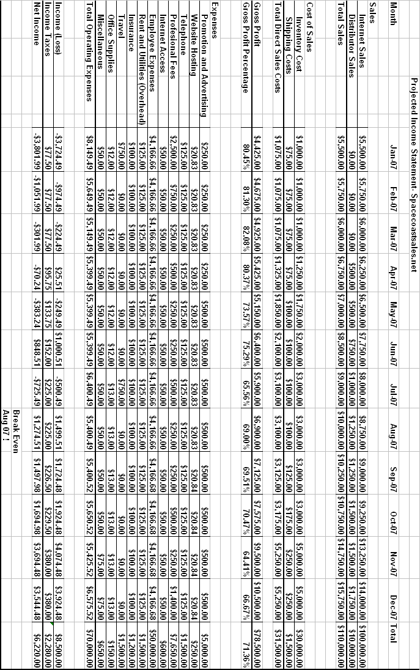
Figure 9. Projected Monthly Income Statement
figure 10. 3 Year Projected Income Statement

Figure 11. Planned Cash Flow

Management Plan-
President- Eric Dahlenburg (42) is the company founder and primary owner. The office of president will oversee all financial decisions and planning. The president will direct others in the normal course of their duties. He will chair the new product committee and have final authority on what products are ordered and what quantities.
Mr. Dahlenburg is a graduate of Brevard Community College with a Associates Degree in Electrical Engineering Technology. Most recently, Mr. Dahlenburg graduated Summa Cum Laude from Kaplan University with a Bachelors degree in Information Technology.
Mr. Dahlenburg has over 12 years experience working in electronic repair and has owned many small businesses. He most recent business, Four Jays of Merritt Island, Inc., a coin operated amusement leasing company, had sales of over 3 million dollars during his last year at the helm.
IT Manager- Shambie Hammett (47) is the IT manager and overall technology developer and maintainer for the business. The IT managers duties include:
-Authoring and updating the company website
-Performing, testing and restoring website and financial data for the company
-Optimizing the website for the highest search engine placement
-Assuring privacy law compliance the merchant payment system and website.

Mrs. Hammett has many years of IT experience with Gannett, e-security, and Titan industries were she maintained networks, websites, and databases for groups of more than 500 users. She has an Associates degree from Brevard Community College and will soon have a Bachelors in Information Technology from Webster University. Mrs. Hammett is a certified Microsoft and Cisco network engineer with many other computer related certifications
Accounting Manager- Joe Moma (55) is the Accounting manager. The position assures that:
- All receivables are received, reconciled and deposited into the bank account
- Shipments received are reconciled with the correct vendor billing
- Perform monthly audits of the general ledger
- Pay all authorized bills through the purchase order system
- Pay all re-occurring overhead bills
- Assure that all sales taxes due in Florida are collected and paid to the state
- Assure that all applicable taxes and unemployment are withheld and
reported for our hourly/salaried employees
- Assist in the quarterly independent audit of financial accounts
Mr. Moma has 35 year experience in corporate accounting, including companies doing business in several different countries. Mr. Moma is a licensed and accredited CPA with a Masters degree in international business accounting and a minor in e-business.
We have chosen outside professionals to work with our business.
Gene Canada from the accounting firm of Brevard Accounting, as our independent auditor, tax consultant, and preparer.
Greg Crutchfield, of the firm Crutchfield and Albert, PA., will be our general counsel. He has extensive experience with business law, internet and privacy, Liability and IPO’s.
Greg and Gene are also members of our advisory board.
Identification of Critical Risks
An e-business faces is not immune to risks. While an e-business can’t burn down like a brick and mortar business, it does have some unique situation. The following is a list of potential problems that could effect the business and how we anticipate addressing the situation.
1. Some of our items are outlawed in areas
This can happen with adult items. We will restrict sale of these items based on the shipping address and make sure the web site reflects this restriction. Furthermore, our lawyers will research each jurisdiction and advise of new restrictions as they become law.

2. Our inventory is destroyed by fire or flood
We carry insurance for just this event. The only thing not covered is loss of business income. Insurance is cost prohibited for this coverage. Regardless, lead time on delivery of most items from our suppliers is under a week. We can still accept orders and ship when the items arrive from the supplier.

3. We lose connectivity for a long period of time
This is highly unlikely, as our web host has redundant servers, nightly backups, environmentally controlled server rooms that are secure and protected from natural disasters. They have generator power and uninterruptible power supplies for intermittent outages. If there is an outage, it will most likely be from internet connectivity. In which case, every business will be effected. If it is caused by a Denial of Service attack, we can coordinate with out internet provider to filter the bad senders from the router. Lastly, in the event that our webhost is totally destroyed, we can always reload the site to another server and only be down for a few hours while the DNS redirects.
4. Postal rates sky rocket
We never quote postage on our items without knowing what it costs. In the event that the USPS is cost prohibitive, there are many other commercial carriers for domestic and international delivery. The only good thing in this scenario is that our competition will have the same problems.

5. Hurricane strikes our office
Since our website is hosted by a third party in California, we will not lose the ability to sell. The company policy is to evacuate the office and transport or secure the inventory. If inventory can be moved to a safe place, it will be done. If the inventory is too large or there are no alternatives for storage, then the inventory will be covered in water proof tarps and left during the evacuation. Once again, we have insurance for this kind of loss.
Exit Strategy
Based on the three year financial plans developed for this business, no exit will be considered until the end of year three. The options include:
1. Raise equity capital and continue with the expansion into Port Canaveral.
This option includes importing goods from off shore and becoming a major distributor and wholesaler (Canaveral Plan).

2. Sell the business outright and take the profits.

3. Use an IPO or other financial instrument to raise money for the Port
Canaveral expansion plan. The president would sell off his shares of the IPO and cash out.

4. Continue to run the business “as is” , collect a good earnings while providing jobs for the local community.

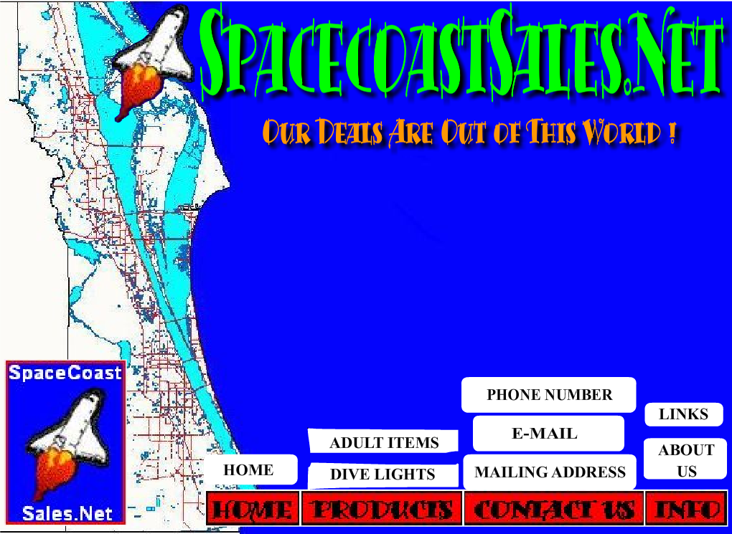
Homepage mock-up including appropriate text, links, and graphics
figure 12. Home page mock-up, Navigation bar Exposed

Figure 13. Loading page to website
Complete site can be viewed at http://spacecoasthomes.net/week8.html
Summary of Required Internet Technologies (WWW, email, etc.)
Internet technologies generally used and required include the following:
Macromedia Flash
Used for designing attractive splash pages as well as entire websites.

HTTP markup language
Used to construct the website. This is the basis for all websites.

Adobe “Go Live”
This is the official web site development software used to develop web pages for our site.

PHP and Perl Scripting
These scripting languages will be used as server side programs to automate all customer forms and e-mail inquiry

Shopping Carts and Secure Socket Layer
While most shopping carts are designed by a third party, knowledge of their function and security is a necessary knowledge.

File Transfer Protocol (FTP)
Used to upload new pages to the server.

Audio and photo editing
Photoshop, Goldwave and other editors will be used to create and edit graphic for the website along with audio files for some of our items.

Log file and Page Tagging (Web Analytics)
These skills will be necessary to track user interaction within the site. The data derived from these techniques will guide the IT manager in modifying the website for optimum use.

Website Security (Antivirus, log scanning, policy creation, etc)
Norton antivirus and hardware firewalls are necessary to keep out hackers. The development of good user policies will also help eliminate viruses and other problems that can bring the site down.

Our IT manager is well versed in these disciplines and will be able to keep our site working perfectly.

Logistics of establishing and maintaining your e-business site
( including any legal or regulatory issues)

Initial site creation is an ongoing effort. Our site must first be created featuring are existing product line. Since products change quickly, the IT manager must be able to quickly update the site with the new products and remove any products that are no longer available. Furthermore, the IT manager must build and analyze the web analytics regularly and modify the website to eliminate abandoned shopping carts and other problems that make the customer disinterested.

Add to that the responsibility of:

1. Maintaining a privacy policy
2. Sales tax collection and reporting
3. Any interstate shipping restrictions
4. Optimizing Web Search engine ranking
5. Securing the backup data from environmental damage or theft
6. Creating a backup policy and testing the backup regularly
7. Creating different language options for the site
8. Assuring that our domain name is registered and renewed correctly
9. Making sure that we have only legal copies of software
10. Making sure that none of our products are knock offs (counterfeit)
11. Making sure that no one can get into our site
12. Making sure that we can detect anyone trying to get into our site
13. Regularly consulting with the lawyer and accountant to assure that we are
in compliance with any and all laws.

Reference

Anon. (2003) Gordon Brothers Group Acquires Spencer Gifts. Retrieved on August 9, 2006 from
http://www.gordonbrothers.com/firm/content.cfm?id=article&pr=14

Anon. (1997) 1997 Economic Census: Retail Trade United States. Retrieved on August 10, 2006 from
http://www.census.gov/epcd/ec97/us/US000_44.HTM

Anon. (2006) United States Small Business Administration. Retrieved on August 8, 2006 from http://www.sba.gov/

Anon. (2006) Vending Services Business Plan. Retrieved on August 10, 2006 from http://www.bplans.org.uk/spv/3043/index.cfm?affiliate=pas

Anon. (2006) Coffee Export Business Plan. Retrieved on August 9, 2006 from http://www.bplans.org.uk/spv/3244/index.cfm?affiliate=mbus

Anon. (2006) Executive Summary- JavaNet. Retrieved on August 10, 2006 from http://www.bplans.com/spv/3142/index.cfm?affiliate=sba

Anon. (2006) eMarketer Analyst Reports. Retrieved on August 8, 2006 from
http://www.emarketer.com/Products/Reports.aspx

Kane, M. (2006) Sample Business Plan: Michael’s Business Centre. Retrieved on August 10, 2006 from http://www.rbcroyalbank.com/RBC:RNkMUo71A8YAAm@Q9Pc/sme/bigidea/michaels.html

Napier, H., Rivers, O. , Wagner, S., & Napier, J. (2006) Creating a winning
E-Business, 2nd ed. Boston: Thomson Course Technology

Estimated 1st Year Expenses: http://www.spacecoasthomes.net/year1.xls

Projected Income Statement: http://www.spacecoasthomes.net/projected.xls

Planned Cash Flow: http://www.spacecoasthomes.net/flow.xls

Projected Monthly Income Statement: http://www.spacecoasthomes.net/monthly.xls

