An Overview of SQL Server Reporting Services

Eric Dahlenburg
IT-476
Diane Dee, PHD.
March 9, 2006

There are many DB workers who have had to write custom reports based on the many data sources in their organization. Once they write the report in one format (Excel for example), they must write it in PDF format for the marketing department, or as a TIFF format for the overseas division and then in a HTML format for the company intranet. Some DB professionals repeat this on a monthly, weekly, and sometimes even a daily basis.
Years ago, there weren’t many applications that could solve this chore. There were reporting tools (Crystal Decisions, Cognos, Inc.),but they didn’t integrate well with some systems. Seeing a need for a solutions in this growing field, Business Intelligence, Microsoft developed “Report Services” for SQL Server 2000. After many enhancements, the current Reporting Services for SQL Server 2005 is a power house of a solution.
But what exactly is Reporting Services (RS)? Reporting Services is a server based application that runs with SQL Server to allow the delivery of pre-defined or ad-hoc reports derived from the SQL Server or other OLAP data sources.
While simple in principle, RS allows these interactive reports to be automatically generated and distributed in many ways. They can be posted to a web portal, e-mailed to technology workers, stored on a report server, and received via personalize subscriptions.
The personalized subscription feature allows users of the report to have it formatted in any way they desire. A marketing manager and a sales manager might receive the same data, but it arrives in totally different formats. These formats can be static or interactive.
RS supports charts, document maps, cross tab matrix, sub-reports, freeform and tables. Furthermore, if they view the report as a URL on the web, certain parameters allow the same URL to display the format selected through the subscription of the particular viewer. RS is capable of other formats besides the web. RS can output reports in XML, HTML, TIFF, CSV, PDF, Excel, War, and can transport these formats through FTP, SMTP (E-mail), and the web.
The benefits of RS are immediately obvious to that poor DB worker who compiles all the organizations reports each day. Everyday reports can be automatically generated from the data sources and delivered in the desired format and file type directly to the technology user. In addition, new reports can be easily created inside RS, using “Report Generator” a graphical authoring tools with intuitive wizards.
From the business point of view, Report Services can automatically generate reports at any interval, be it weekly, daily, or hourly. Without an automated report generator, a DB worker must construct all reports by hand using different and dissimilar tools which might cause the reports to be released on a monthly basis instead of daily. On-demand reporting allows the business to react quickly to opportunities or to consolidate resources. As an example, Cox Communications uses Report Services to monitor the status of its Telephony, Cable TV, and High Speed Internet services. When a fiber optic cable is interrupted, it causes trouble reports for all three services and duplicates the repair overhead. Report Services interactive nature allows for better data so that one repair crew can be sent to repair the fiber, rather than three repair crews to investigate all three services.
In addition, with their data warehouse and report services, they switch from being reactionary to repairs to being able to use historical data to determine were to direct preventive maintenance prior to a potential outage. The report generator in conjunction with data mining, allows for intelligent maintenance reports to be generated that effectively predict where the next problem will occur (based on historical warning signs). With 6.3 million customers, Cox communications loses considerable revenues when there is an outage.
The benefits of report services are primarily realized by large and mid-size businesses, especially those utilizing a data warehouse. Cox Communications is considered a large business user. So large, in fact, that they add over half a gigabyte of data to their database daily.
To use report services, you must have a local or remote instance of Microsoft SQL Server with Service Pack 3a. Report Services comes in different versions depending on the version of SQL Server. SQL Server Enterprise edition requires the enterprise edition of report services, SQL Server Professional requires the professional version of report services.
Report Services can be installed on a separate server from SQL Server to reduce overhead or installed on the same server. The configuration of the installation dictates the licensing arrangement. An installation of report services on the same server as SQL Server is covered under the licensed copy of SQL Server. However, if report services is installed on a separate server from SQL Server, a separate license must be purchased.

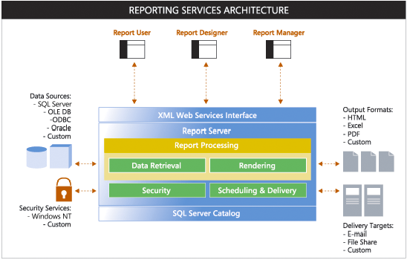
Since report services is integrated with .NET, .Net framework and ASP.NET are both required for the installation. The “Report Designer” component of report services requires Visual Studio.NET. Individual copies of Visual C#, VB.NET, or Visual C++ can be used instead of Visual Studio.NET. Since software is always in flux, it is recommended that the administrator check for current updates and service packs.
Figure 1. Typical Report Services Architecture
In addition to Cox Communications, there are many other companies that have successfully used the report services solution. Mary Kay, Inc., a fortune 500 company specializing in skin care and cosmetics, benefits from the power of report services.
In 2002, Mary Kay had 1.4 billion dollars in wholesale sales through its independent sales force. This represented over 85 percent of Mary Kay’s total revenue. Independent sales people rely on the internet, phone and fax to communicate orders and receive various sales and income reports from Mary Kay.
Mary Kay depended on old mainframe technology to run its operations and initiated a multimillion dollar upgrade of its technology infrastructure.
This upgrade consisted of replacing the existing mainframe with Microsoft Server 2000 and SQL Server 2000. They initially used Crystal Reports as part of their Business Intelligence initiative to generate reports form data in SQL Server, Peoplesoft, and PKMS (a warehouse management solution). The company expanded this technology initiative in 2003 to its four warehouses. With this upgrade, Mary Kay would need to switch from Crystal Reports to Crystal Enterprise. It was decided that the Crystal Enterprise solution was cost prohibitive and would not meet the needs of all their users. They replaced Crystal Solutions with Report Services.
Hitachi Consulting, the Microsoft gold vendor handling the initiative had this to say about the change
“By switching from Crystal Reports to Microsoft SQL Server Report Services, the company will benefit from a single environment that covers all phases of the enterprise reporting life cycle-- from report development to management and delivery. Reporting Services eliminates the need for Mary Kay to purchase or develop advanced reporting features by hand, saving the company significant software and development costs. As a result of this new reporting solution, Mary Kay will benefit from faster report creation and performance, reduced software licensing cost, and an enhanced end-user experience”.

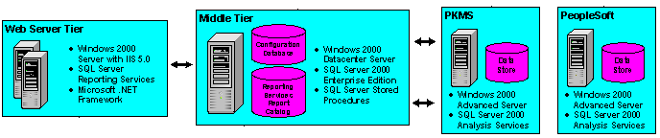
Figure 2. Mary Kay’s Technology Infrastructure
The new solution supported the generation of over 300 different reports. Furthermore, these reports are generated in real-time using report caching. Prior to this change, some reports took 45 to 90 minutes to generate. This caused significant overhead on the back-end hardware which would have been unacceptable once the four warehouses and additional users were integrated into the system.
Report Delivery and subscription allowed all the independent sales people and internal company personnel to access reports through the web portal and
e-mail. In addition, the reports were available in many file formats which allowed the importation of the data into various desktop applications for further analysis.
Mary Kay is one of many companies that have benefited from SQL Server and Report Services. Others including RF Micro Devices, CompUSA, MTV Europe, Ruby Tuesday, Barnes and Noble, Inc., and Hilton Hotels.

Bibliography

Anon. (2003) Microsoft SQL Server Customer Solution Case Study: Mary Kay.
Retrieved on March 7, 2006 from:
http://members.microsoft.com/CustomerEvidence/search/EvidenceDetails.aspx?EvidenceID=2566&LanguageID=1

Anon. (2003) Microsoft Business Intelligence Customer Solution Case Study: Cox
Communications. Retrieved on March 8, 2006 from
http://members.microsoft.com/CustomerEvidence/search/EvidenceDetails.aspx?EvidenceID=2547&LanguageID=1

Anon (2006) Benefits of Reporting Services in your application. Retrieved on
March 9, 2006, from: http://www.microsoft.com/sql/technologies/reporting/leveragingrs.mspx

Anon. (2004) Microsoft SQL Server Customer Solution Case Study” Long & Foster
Companies. Retrieved on March 8, 2006 from http://members.microsoft.com/customerevidence/search/AdvancedSearchResults.aspx?Flag=0&AndTaxID=23913

Anon. (2006) Report Services Overview. Retrieved on March 9, 2006, from
http://www.microsoft.com/sql/technologies/reporting/overview.mspx

Masoon, A. (2004) 15 Seconds: Business Intelligence with Microsoft SQL Server
Reporting Services- Part 1. Retrieved on March 7, 2006 from
http://www.15seconds.com/issue/041013.htm

Niccolai, J. (2004) Microsoft launches SQL Server Reporting Service. Retrieved on
March 9, 2006, from http://computerworld.com/printthis/2004/0,4814,89454,00.html

